FROM THE DESK OF
SANTA CLAUS

Dear Peter,
It is with great regret that I send this warning letter. I have already found out who is naughty or nice, as well as I have made my list and checked it twice. Although you have been good for the most of the year, Elfie has reported many bad choices from you and you are very close to the Naughty List.
@WWW.CLICK-ME.TODAY

You still have a week to secure your spot on the Nice List. Elfie will be peeking through your window to check on your behavior – be sure that you speak kindly, play calmly, tidy your room and help your parents.
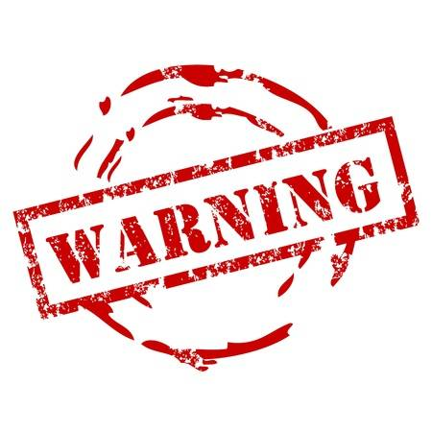
I am sure that you prefer my present than some clothes...!
Elfie is watching,
Santa Claus

